Gradient descent is an iterative method of optimization which is used to search for a local minimum of a differentiable function. It is used intensively in machine learning algorithms to find the minimum of a cost function. The idea is to take steps in opposite direction of the gradient of a function in the current point since this is the direction of steepest descent (<https://en.wikipedia.org/wiki/Gradient_descent>). Gradient descent is used at least in neural networks, linear and polynomial regression, as well as in logistic regression.

Basically, the idea is to find the partial derivatives of a function – typically of a cost function, compute the gradients and then update the weights of a cost function. Let’s consider polynomial regression. To find parameters of a function which guarantee best fit for the empirical data one can use the gradient descent algorithm. In polynomial regression the cost function is typically defined as follows:

$$J=\frac{1}{2n}\sum_{i=0}^{n}{{(y_{i}-Θx_{i})}^{2}}$$

The gradients are:

$$\frac{∂J}{∂θ}=\frac{1}{n}\sum_{i=0}^{n}{(y_{i}-Θx_{i})(-x_{i})}$$

And finally, the update rule is:

$$θ=θ - α\frac{1}{n}\sum_{i=0}^{n}{(y_{i}-Θx_{i})(-x_{i})}$$

Where $α$ is a learning rate.

In the figure below we show an example of how polynomial regression can be used to fit the empirical data:

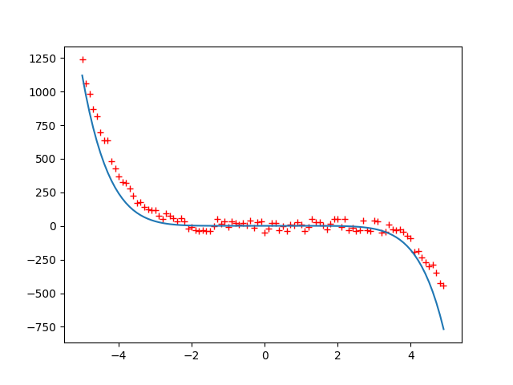

The original function that was used to generate the data is $y=-0.3x^{5}+0.5x^{4}+{0.5x}^{3}+x^{2}+0.6x$

The hardest part is to assign the initial values for the coefficients, specify the learning rate, and choose appropriate lambda value.

The source code for the polynomial regression is shown below:

from random import uniform

from math import sin

from numpy import arange

from numpy import dot

from matplotlib import pyplot as plt

import numpy as np

from math import *

def generate_sequence(n, step=1):

for i in arange(-n, n, step):

yield 0.5*i*i*i*i+0.5*i*i*i+1*i*i+0.6*i

gen = generate_sequence(5, 0.1)

seq = []

for elem in gen:

elem += uniform(-50, 50)

seq.append(elem)

x = arange(-5, 5, 0.1)

x = np.array(x)

bias = np.repeat(1, int(10/0.1))

x1 = np.vstack((x, x*x))

x2 = np.vstack((x1, x*x*x))

x3 = np.vstack((x2, x*x*x*x))

x4 = np.vstack((x3, x*x*x*x*x))

x5 = np.vstack((x4, x*x*x*x*x*x))

x6 = np.vstack((x5, x*x*x*x*x*x*x))

x7 = np.vstack((x6, bias))

x = np.transpose(x7)

y = seq

theta = [0, 0, 0, 0, 0, 0, 0, 1]

def cost_function(theta, x, y):

h = np.dot(x, theta)

n = np.shape(h)[0]

d = np.transpose(y) - h

return np.dot(np.transpose(d), d)/(2*n)

def d_cost_function(theta, x, y):

h = np.dot(x, theta)

n = np.shape(h)[0]

d = np.transpose(y) - h

return -1*np.dot(np.transpose(d), x)/n

epsilon = inf

iter = 0

learning_rate = 0.0000000000001

while epsilon > 0.01:

c1 = cost_function(theta, x, y)

theta = theta - learning_rate * d_cost_function(theta, x, y)

c2 = cost_function(theta, x, y)

epsilon = c1 - c2

iter += 1

x = arange(-5, 5, 0.1)

x = np.array(x)

x0 = arange(-5, 5, 0.1)

bias = np.repeat(1, int(10/0.1))

x1 = np.vstack((x, x*x))

x2 = np.vstack((x1, x*x*x))

x3 = np.vstack((x2, x*x*x*x))

x4 = np.vstack((x3, x*x*x*x*x))

x5 = np.vstack((x4, x*x*x*x*x*x))

x6 = np.vstack((x5, x*x*x*x*x*x*x))

x7 = np.vstack((x6, bias))

x = x7

plt.plot(arange(-5, 5, 0.1), seq, 'r+')

plt.plot(x0, np.dot(np.transpose(theta), x))

plt.show()